Text | Writing Opportunities | Links to Continuous Provision
Term 1 (3 wks)  There's a Dragon At My School,  Philip Hawthorn  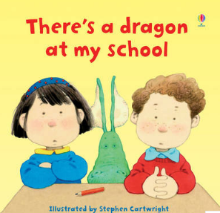 | Name Writing/Pencil Grip  Mark Making | - Walk around the school  - Autumn walk to collect leaves  - Paint a friend  - Drawings of school activities  - Order and sequence the school day  - Self portraits  - Leaf pictures
Term 1 (4 wks)  The Gingerbread Man  (Traditional Tale)  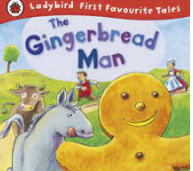 | Name Writing  How to draw a gingerbread man  Sequence parts of the story | Links to continuous provision  - Making and eating gingerbread  - Role play with a cafe  - Role play with a kitchen - cutters/play dough  - Decorating biscuits and selling them  - Make laminated puppets of the character to retell the story
Term 2  The Little Red Hen (3 Wks)  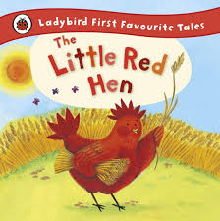 | Name Writing  How to draw a hen  Describe a character - The hen is red  Describe wheat/bread.  Sequence the story | Links to continuous provision  - Have a picnic  - Walk in the woods  - Make dough.  - Visit a bakery  - Buy bread
Iris and Issac  (3 Wks)  by Catherine Rayner  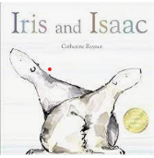 | Simple Labelling. It is snow. It is ice. It is cold. It is wet. Issac is a bear, Iris is a bear.  Write sentences linked to feelings  Write sentences linked to setting | - Melting ice  - Drawings of favourite part of the story  - Explore tonal range to create their own icy pictures  - Make laminated pictures of Otto and use to support retelling the story  - Create the world of the story in a tray choosing appropriate materials to represent the sea and ice
Term 2 (1 wk)  Little Robin Red Vest  by Jan Fernley  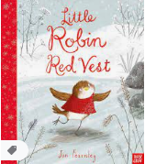 | Sentences to describe the vest for Robin  Thank you letter | Links to continuous provision  - Make a vest  - Make a present  - Sing the Robin Song  - Make a Robin Red Breast
Term 3 (4 Wks)  Goldilocks  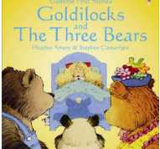 | Storymap and retell with actions  Describe a character. The bear is big.  Setting description. The chair is big.  Instructions for making porridge | Links to continuous provision  - Make porridge  - Have a picnic  - Walk in the woods  - Role play outside and inside
Term 3  Naughty Bus by Jan Oke  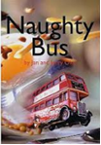 | Storymap and retell with actions  Use pictures from story to write about the bus e.g. The bus is red and fast.  Draw a picture of the bus - I will not be bad and go in the …...  Name writing | Links to continuous provision  - Bus Ride on the Metro Bus  - Recovery truck to visit  - Walk to bus stop

Term 4:  Jack and the Beanstalk  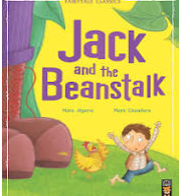 | Describe the giant. He is tall. He is mad. He sees Jack.  Describe the journey of Jack: He ran and met a giant. He ran into the sky and saw a goose. He ran to the door and saw an egg.  Write about visit to a garden. We went to the ………  Write about planting a seed. I can dig, I can put, I can use | Links to continuous provision  - Making and eating gingerbread  - Role play with a cafe  - Role play with a kitchen - cutters/play dough  - Decorating biscuits and selling them  - Make laminated puppets of the character to retell the story
Term 4  Surprising Sharks  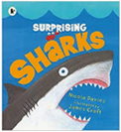 | Write some facts about sharks - Sharks have sharp teeth. Sharks can swim in the sea. Sharks lay eggs to have babies. Sharks hunt for prey. Sharks can go under water.  Draw a picture of a shark and label it as a scientist - fin, gills, eyes, teeth, tail, skin, jaw,  Describe the real fish and visit by the fisherman  Describe under the sea. Refer to pages in the books. I can see a red crab. I can see a small yellow fish. I can see coral and seaweed | Links to continuous provision  - Look at a variety of real fish eg sardines, Mackerel, etc and describe what they can see  - Invite a diver to visit with their equipment  - Making non fiction fact books with images from the book using the different sharks and small books.
Term 5:  Bog Baby  Jeanne Willis  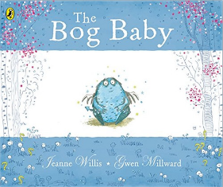 | Generate sentences eg In the woods I saw tall trees. In the woods I saw yellow flowers. In the woods I saw green grass.  Write a description about the bog baby. My bog baby has blue skin.  Write sentences about what the bog baby needs | Links to continuous provision  - Go for a walk in the woods  - Make a Bog Baby and make a home for Bog Baby  - Seasons  - Make a Bog Baby(pom poms, play dough, plasticine etc).  - Make a home - collection of shells/stones/leaves/chinese tubs etc  - Read some non fiction books about wild animals - what do they need?  - Shells
Term 5:  Enormous Turnip  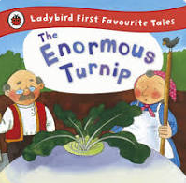 | Story map and retell of the story  Describe the turnip  Use pictures to retell and sequence the story.  Write sentences describing who pulss the turnip | Links to continuous provision  Drawn and label turnips  Make turnips  Explore real turnips  Plant seeds  Gardening including pulling the weeds up  Explore the characters in role play
Term 6  Errol's Garden  By Gillian Hibbs  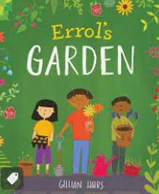 | Write sentences about what they are good at.  Write sentences ‘I like...’ and ‘I do not like...’ to describe different fruits and vegetables.  Sequence the pictures:  I dug a hole.  I planted a seed.  I watered my seed.  I saw my flower.  Write Errol’s plan. | Links to continuous provision  Continue growing theme  Nature walks  Drawn and paint vut up fruit and vegetables  Sort and match fruit and vegetables  Tally charts of tasting different things  Use a variety of gardening tools and watering.  Ask questions to a gardener.
Term 6  Good Little Wolf  By Nadia Shireen  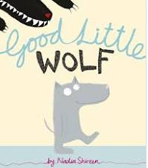 | Label a picture of the wolf  Write sentences to describe the wolf and explain why he is good  Story map and oral rehearsal of story  Retell the story | Links to continuous provision  Made wolf pictures  Make ears to wear  Guided drawing and painting  Use different materials e.g. furry materials to collage

