Text | Main Unit Outcomes | Other Writing Opportunities
Term 1  The Golden Cage  by Anna Castagnoli  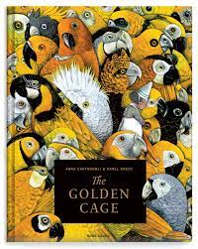 | Fiction: The true story of what happened to the egg  Non-Fiction: Report about Birds | - Character description of Valentina  - Setting description of the palace  - Summary from an idea from the end of the book  - Blurb for Non Fiction Text  - Introduction for Non Fiction Report
Term 2  Leo and the Gorgon's Curse  by Joe Todd Stanton  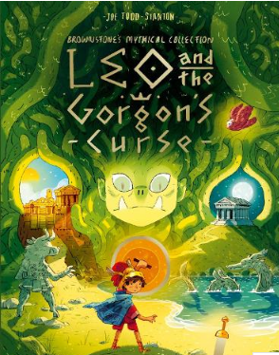 | Fiction: Write the full story of the Gorgon.  Non-Fiction:  God Wars (Argument) | - Description of Athena  - The Arrow and the Sea Serpent - recount  - Information leaflet – Greek Gods  - Factsheet – Ancient Greece  - Formal and informal style – write in one and then the other.
Term 3  Wisp: A Story of Hope  Zara Fraillon & Graeme Baker-Smith  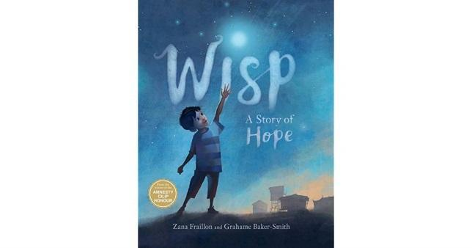 | Non-Fiction: Recount  Write a series of diary entries (for Idris, the Old Man, the woman)  Narrative: Their own story of hope | - Description of Idris’ ‘small, small world, including his feelings.’  - Old Man’s Diary  - Old Woman’s Diary  - Hope Poem
Term 4  The Moth by  Isobel Thomas  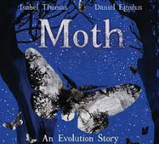 | Non-Fiction: Explanation text of Moth  Non-Fiction: Evolution Report in style of author  Non-Fiction - Evolution Instructions (SEND) | - Summary for the book  - Innovated text from the first part of the book  - Innovate the middle sequence  - Introduction to explanation

Term 5  The Fox  by Isobel Thomas  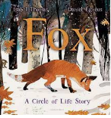 | Fiction: Francis (literacy Shed)  Narrative Non-fiction: Story explanation of Fox. | - Innovated passage in the style of the author  - Fiction SATs writing
Term 6  Rose Blanche,  by Ian McEwan  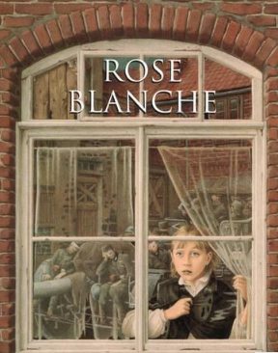 | Fiction: Retell story in own words  Non-Fiction:  Report – WW2 (own choice of focus) | - Setting description – before the war  - Setting description – after the war  - Character description of Rose Blanche  - 1st person diary entry – Rose Blanche

