Text | Main Unit Outcomes | Short Burst Writing
Term 1  Town is by the Sea by Joanne Schwartz  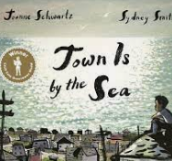 | Write a day in the life of a coal miner  Write a setting description of the town  A day in the life of a boy as a diary, including his feelings  Write a diary  Write about what their future might be and what they need to do to get there.  Write a biography | - Watch historical videos about mining/artefacts  - Factual sentences about the future  - Diaries  - Understand what mining was like- real life interviews if possible from a historical archive
Term 2  Way Home by Libby Hathorn   | Paragraph based on the front cover of the book/first picture  Plot emotions and use drama  Diary entry for the final part of the journey, including thoughts and feelings  Write a character description of Shane  Paragraph about homelessness  Put the writing together to create a magazine article- add final paragraph | - Drama  - Collect information from charities  - Hug the text and vocabulary  - Newspaper reports
Term 3  Colin Thompson  T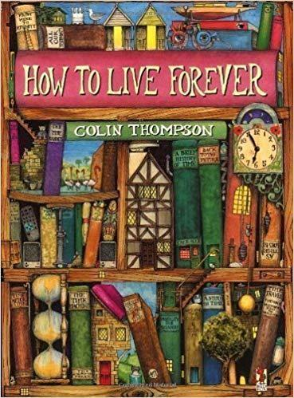 | How To Live Forever  Write a description of he illustration using sentences e.g. I opened my eyes and saw,,,  Peter’s recount when he met the ancient child.  Write why Peter decides not to read the book.  Retell and write the story.  Argument for living forever  Write letter | - Reading Journal  - Journal from the lost child’s point of view  - Rewrite using formal language

Term 4  The Promise by Nicola Davies  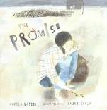 | Description of the city  Pick one area (eg the park) and write a short paragraph to say why people should visit  Plan and write a non-chronological report  Create a fact file for the old lady  Plan the story of the old lady | - Build up the picture of the city  - Noun phrases  - Atmosphere  - Growing and seeds
Term 5  The Lost Thing  by Shaun Tan  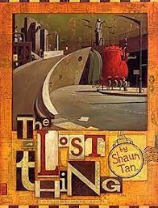 |  | - Character description of narrator from story of Lost Thing  - Setting description  - Innovation about the afternoon
Term 6  Mr Hirota's Phone Booth  Heather Smith  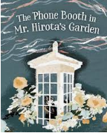 |  | - Setting description of the Tsunami  - Character description of Makio  - Setting description for calm ocean

