Text | Main Unit Outcomes | Other Writing Opportunities
Term 1  Last by Nicola Davis  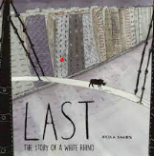 | White rhino at the start of his life  Drama to support the writing of rhino in the zoo  Boxing up and story map to write the story (with editing)  Sentence writing about rhinos  Persuasive piece about rhinos | - Book talk and vocabulary focus  - Learn about rhinos and their features- watch videos and wider reading  - Sentences about rhinos after asking lots of questions  - Write persuasive sentences about rhinos  - Formality when writing
Term 2  The Glassmaker’s Daughter  by  Dianne Hofmeyr  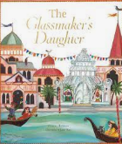 | Factfile about Venice- facts and sentences (include glass blowing)  Power of three within sentences  Story map  Make a mask and write a description (including editing and rewriting)  Sentence writing about Venice- more detailed  Report about Venice based on the pervious writing | - Write about Venice/glass blowing after watching videos and reading around the place  - Oral rehearsal  - Description of setting  - Description of masks  - Key vocabulary explored and shown through objects
Term 3  Leon and the Place Between  Angela McAllister  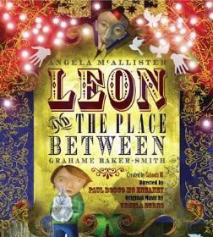 | Book review  Short descriptive paragraph based on one of the pictures using the language practiced.  Draw a picture of their fairy land and annotate it  Box up and then write part of the story  Recount the circus day in detail  Persuasive leaflet | - Book Reviews in general  - Description of one of the pictures in the book  - Key vocabulary explored and ‘lived through a circus day- Brave Bold Drama is a link (CBR)  - Recount of Circus Day

Term 4  Wolves in the Wall  By Neil Gaiman  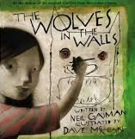 | Letter of complaint from Lucy to the wolves  Story map and letter to the headteacher about the wolves  Write the story  Fact file about wolves  Written report about the wolves | - Letter to Head about Wolves in the school  - Fact File about Wolves  - Factual sentences about wolves  - Discrete grammar teaching  - Searching for wolves  - Teaching of paragraphing key
Term 5  Marcy and the Riddle of the Sphinx  By Joe Todd Stanton  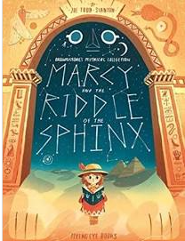 | Sentences and a description of Macey  Rewrite the scene when Macy met Thoth  Boxing up and description of Ra  Write a paragraph from the story  Introduction to an explanation text about Egyptians  Complete explanation/ instructions texts | - Description of a monster  - Scene between two people including dialogue  - Character description of Arthur.  - Watch and learn about the Egyptians  - Look at artefacts  - Instruction examples
Term 6  The Moon Dragons  by Dyan Sheldon  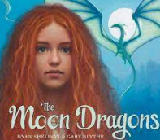 | Description with adverbial phrases  Write a description of the King  Write a description of Elina  Sentences to practice formal language  Write an argument  Verbal debate | - Moon Dragon description  - How to catch a moon dragon  - College of moon etc  - Imagery explored  - Debates and opposition sides explored

