Text | Main Unit Outcomes | Other Writing Opportunities
Term 1  The Wolf, the Duck and the Mouse  by  Mac Barnett  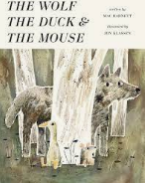 | Rewrite a fable  Retell what happens when the mouse gets eaten  Write the meeting of duck and the mouse with speech  Write about the duck in the wolf’s stomach  The duck’s story  Write about what the duck eats | - Watch videos and learn about ducks and wolves, including what they eat.  - Explore forests and the setting  - Read fables- the lion and the mouse  - Book talk and drama  - Read texts with speech
Term 2  The Flower  by John Light  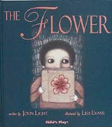 | Describe the setting including the feelings and character’s feeling about the city  Character description of how the boy felt when he lost the flower  Description of how Brigg felt at the dust heap  Retell the story of the flower using previous weeks writing  Instructions on how to plant seeds.  Write sentence about caring for plants.  Write an instructional leaflet about plants | - How to plant seeds e.g. cress  - Caring for plants  - Reread and recap the Tin Forest from Y2  - Look at videos and pictures of cities to understand metropolis e.g. Central Park in New York, Hampstead Heath in London.  - Time lapses of flowers growing and dying.  - Read non-fiction books about plants.  - Errol’s Garden YR book
Term 3  Winter’s Child  Angela McAllister  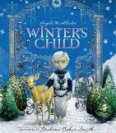 | Winter setting description (Page 17)  Character description  Retell the story in Tom’s voice including his feelings  Tom explains why he has stopped playing.  Diary entry as Winter’s child in response to Tom  Discussion text. | Learn about Winter.  Watch videos  Background knowledge of farming, folklore and the season.
Term 4  Hortense and the Shadow by Natalia and Lauren O Hara  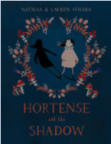 | Letter from the shadow to Hotense  Setting description  Writing in first person as Hortense about the darkness but before the bandits appear  Retell story from the shadows point of view  Write a description of a bandit  Newspaper bulletin | - Discussing language- bandit and associated words  - Explore darkness  - Watch the film ‘Before the Sunrise’ and write the opening scene using noun phrases.
Term 5  Mrs Noah's Pockets by Jackie Morris  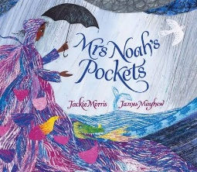 | Mrs Noah- retell the story of Noah’s Ark  Character description of Mrs Noah  Setting description of the rain  Retell the story in their own words using dialogue  Write to inform- report on a magical creature e.g unicorn | - Description of the rain and floods  - Watch the story of Noah’s Ark- picture book  - Dialogue practice  - Drama to bring this to life- concentrate on the grammar (past progressive and past perfect)
Term 6  The Misadventures of Frederick  by Ben Manley and Emma Chichester Clark  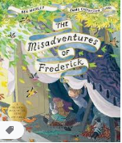 | Instructions for a paper aeroplane  Character description of Fredrick  Letter to Emily  Write the first three paragraphs off the story to do with the hornets  Write a persuasive letter from Emily to Fredrick’s mother | - Focus on formal and informal language  - Letter writing and reading  - Understand what a hornet is

