Text | Main Unit Outcomes | Other Writing Opportunities
Term 1  The Woods  by Rob Hodgson  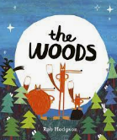 | Write a description of the forest (page 1 and 2)  Sentences to describe the fox’s journey  Retell the story  Write the rabbit’s trek  What did they see and where did they walk?  Choose a woodland animal and write sentences about it (non-fiction)  Write a report about the animal. | - Book talk  - Farming- how carrots are grown  - Describe the woods  - Sentences using prepositional language  - Learn about rabbits, foxes and their habitats  - Recount of autumn walk in woodland  - Role play a camp fire  - Non-fiction books about animals
Term 2  The Tin Forest  Helen Ward  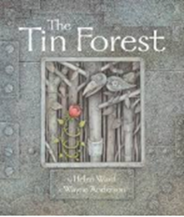 | Write sentences about what else could be in the forest.  Generate ideas and sentences about what the man might do in the forest.  Write the story of the old man in the forest, planting a seed and then something unexpected grows.  Non-fiction of a walk in the woods  Non-fiction persuasive/command sentences about the forest  Record children verbally explaining three reasons to visit the forest (with commands)  Non-fiction advert to come to the forest- include descriptive writing from week two and commands from last week.. | - Sentences about what could unexpectedly grow in the forest  - Sentences about what you might do in the forest  - Recount of walk  - Persuasive sentences about the forest  - Oral persuasive sentences about forest visit with a command  - Planting seeds
Term 3  Lila and the Secret of the Rain  David Conway  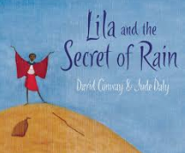 | Fact file one preparation (sentences)- Kenya introduction, where is it…  Fact file two preparation (sentences)- Kenya habitats, everyday life…  Compile the fact file with headings  Sentences about Lila’s feelings  Description of the village  Write a diary to discuss how Lila went up the mountain | - Description of the village  - Watch videos and read about Kenya  - Use Lyfta to learn about Kenya  - Story map  - Book talk  - Compare weather between Bristol and Kenya, watch weather reports, look at maps, look at mountains.
Term 4  The Invisible  By Tom Percival  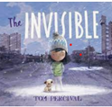 | Write sentences about Isabel’s home before.  Write sentences about Isabel’s home after.  Bring together week one and week two’s writing to retell the story.  Sentences to describe the playground  Write sentences describing how the playground should be changed.  Write a persuasive letter about how the playground should be changed. | - Setting description of the book cover  - Character description  - Setting description of final page  - Non-fiction description of playground  - Debate/discussion - why we should improve our playground (using because)

Term 5  Grandad’s Secret Giant  David Lichfield  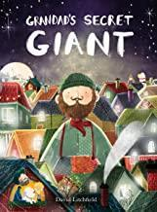 | Sentences to describe the giant’s feelings.  Description of this giant.  Retell the story.  Ingredients for a good friend  Instructions on how to be a good friend to a giant.  Explanation- why is it important to be a good friend. | - Letter from the Giant  - Friendship books and videos  - PSHCE focus  - Discussions about feelings
Term 6  The Marvellous Moon Map  by Theresa Heapy  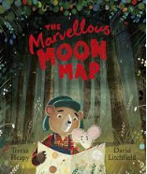 | Description of the moon  Character description of the mouse  Description of the storm  Story of the mouse and the bear finding the sun  Instructions to make a paper boat. | - Describe the moon map  - Hug the text about the sun  - Learn about mice and bears  - Draw maps  - Make paper boats

