Progression in Writing at BLC Primary
YN | Nursery
YR | Reception
 | 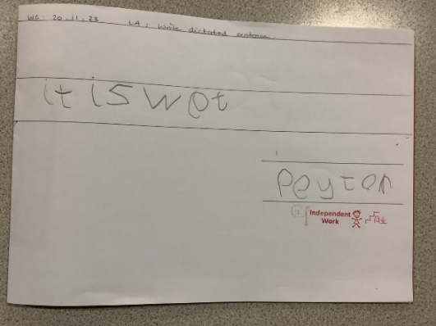
 | Compostion
- Gives meaning to marks they make as they draw, write and paint
- Writes simple lables/captions
- Attempts to write simple sentences
- Writes simple sentence which can be read by themselves
 | Punctuation, Spelling and Handwriting
- Uses phonic knowledge to write simple words
- Writes some HFWs from list 1
- Spells correctly some words
- Writes some phonetically plausible words
- Uses some clerly identifiable letters to communicate meaning
- Represents some sounds correctly and in sequence
- Writes own name
- Begins to form recognisable letters
- Holds pencil correctly

Y1 | Year 1
 | 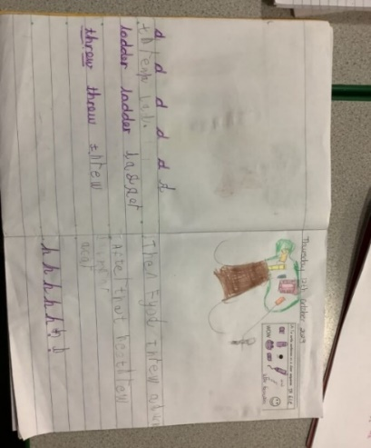
 | Sentence Construction & Conjunctions
- Understand that words combine to make a sentence
- Write simple sentences and compound sentences using basic conjunctions (e.g. and)
 | Noun Phrases
 | - Use adjectives to make their writing more interesting
 | Composition
- Say out loud what they are going to write about
- Orally rehearse sentences before writing
- Compose and sequence sentences to form a narrative
- Check their own works make sense by reading it aloud
- Discuss what they have written with the teacher or other pupils
- Write simple dictated sentences
 | Punctuation
- Begin to punctuate sentences using capital letters and full stops, question marks and exclamation marks.
- Use finger spaces between words.
- Use capital letters for proper nouns (e.g. names of people, places, the days of the week, months of the year) and the personal pronoun “I”
 | Handwriting
- Form letters and digits, starting and finishing in the right place and keeping their writing on the line.
- Sit correctly at a table, holding a pencil comfortably and correctly (tripod grip).
- Form capital letters of appropriate size.
- Leave spaces between words.
- Understand which letters belong to which handwriting ‘families’ (i.e. letters that are formed in similar ways) and to practise these
 | Spelling
 | - See NC 2014
 | Standard English
 | - Begin to use some of the features of standard English e.g. “I saw…” rather than “I seen…”
 | Terminology
letter, capital letter
word, singular, plural
sentence
punctuation, full stop, question mark, exclamation mark

Year 2
Y2 | 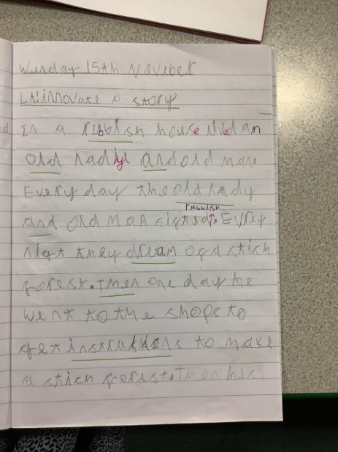
 | Sentence Construction & Conjunctions
- Use coordination (e.g. or/and/but) and some subordination (e.g. when, if, that, because) to join sentences
- Use sentences with different forms (statement, question, command and exclamation)
 | Noun Phrases
 | - Use expanded noun phrases to describe and specify
 | Adverbials
 | - Begin to use adverbials with one word to show when and how
 | Verbs
- Use the present and past tense mostly correctly and consistently
- Use the progressive form of verbs in present and past tense to mark actions in progress
 | Composition
- Write simple and coherent narrative about personal experiences and those of others (real or fictional); write about real events, recording these simply and clearly
- Write for different purposes, including poetry
- Orally rehearse sentences before writing
- Write down ideas and/or key words, including new vocabulary
- Read and edit their writing to make corrections
- Sustain their concentration and effort to produce longer pieces of writing
- Evaluate their writing with their teacher and other learners
 | Punctuation
- Demarcate most sentences in their writing with capital letters and full stops, and use question marks correctly when required
- Use the punctuation taught in Key Stage One mostly accurately
- Exclamation marks
- Commas in a list
- Apostrophes for contractions
- Apostrophes for singular possession
 | Handwriting
- Correctly form letters, letters and digits (including size, orientation, spacing, awareness of joining and relationship to one another)
- Start using some of the diagonal and horizontal strokes needed to join letters and understand which letters, when adjacent to one another are best left unjoined
- Sit correctly at a table, holding a pencil comfortably and correctly (tripod grip)
- Form ascenders and descenders so that they are distinguishable
- Writing sits on the line
 | Spelling
 | - See NC 2014
 | Standard English
 | - Begin to use some of the features of standard English and edit their writing as a result of this (see exemplification)
 | Terminology
 | noun, noun phrases  statement, question, exclamation, command  compound, suffix | adjective, adverb, verb  tense (past, present)  apostrophe, comma

Year 3
Y3 | 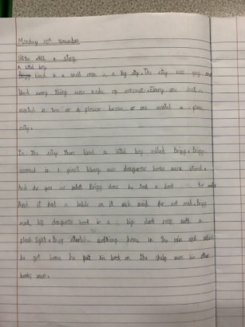
 | Sentence Construction and Conjunctions
- Compose and write compound and complex sentences independently using a wider range of clauses (i.e. subordinate and compound)
- Express time, place and cause using conjunctions e.g. Coordinating: FANBOYS: for, and, nor, but, or, yet, so; Subordinating: when, before, after, while, because, as, if, although
- Express time, place and cause using prepositions e.g. before, after, during, in, here, outside, over, through, next, because, of, by, with
- Express time, place and cause using adverbs e.g. when, next, soon, later, therefore, however, after
 | Noun Phrases
- Use expanded noun phrases with adjectives before the noun and further description after it, using relative pronouns (who, which, that)
- Use a variety of description e.g. adjectives, adverbs, similes, alliteration
- Use varied and effective vocabulary including specific, technical language
 | Adverbials
 | - Use fronted adverbials for time, place and manner
 | Cohesion
 | - Begin to group related information into paragraphs (both fiction and non-fiction e.g. subheadings)
 | Verbs
 | - Use the simple past, present perfect and progressive verb forms in their writing
 | Composition
- Write for a range of audiences and purposes
- Introduce authorial voice and viewpoint in their writing
- Develop character, plot and setting in narrative writing
- Write for a sustained period with a clear structure
- Plan, draft, evaluate and edit writing
- Discuss writing similar to that which they are planning to write in order to understand and learn from its structure, vocabulary and grammar
- Assess the effectiveness of their own and others; writing and suggest improvements
 | Punctuation
- Accurately use punctuation learnt in Years 1-2:
- Question marks
- Exclamation marks
- Full stops
- Apostrophes for contraction
- Commas in a list
- Possessive apostrophe (singular)
- Use inverted commas to indicate speech
- Punctuate subordinate clauses with a comma
 | Handwriting
- Use fluent, legible handwriting which is mostly joined
- Use consistent letter sizing, ensuring that ascenders and descenders are an appropriate length and capital letters are distinguishable
- Adopt an appropriate writing posture, ensuring one hand in on the paper
- Use the tripod grip when writing. When appropriate, without a pencil grip
 | Spelling
 | - See NC 2014
 | Standard English
 | - Use some of the features of standard English and edit their writing as a result of this (see exemplification)
 | Terminology
 | Preposition, conjunction  Paragraph  Progressive verb | Word family, prefix  Clause, subordinate clause  Direct speech | Consonant, consonant letter vowel, vowel letter  Inverted commas (or speech marks)

Year 4
Y4 | 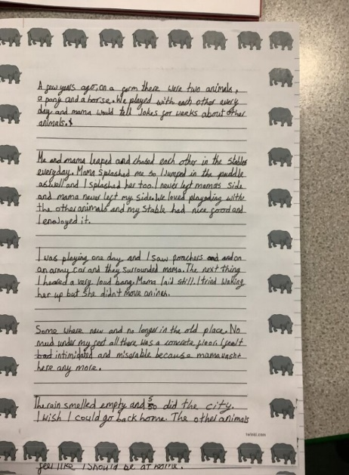
 | Sentence Construction and Conjunctions
- Confidently compose and write compound and complex sentences
- Use a wider range of subordinating conjunctions (e.g. besides, although, by contrast) to write more complex sentences, as well as using a wider range of co-ordinating conjunctions (FANBOYS: for, and, nor, but, or, yet, so)
 | Noun Phrases
- Use expanded noun phrases containing adjectives, relative pronouns, nouns and prepositions
- Use a variety of description e.g. similes, alliteration, adverbial clauses, metaphors
 | Adverbials
 | - Use fronted adverbials for time, place and manner
 | Cohesion
 | - Use paragraphs to organise ideas around a theme and use nouns and pronouns appropriately for cohesion and clarity within a paragraph
 | Verbs
 | - Use the simple past, present perfect and progressive verbs forms in their writing
 | Composition
- Is able to write for a sustained period of time
- Recognise and use a formal and informal style and language
- Develop character, plot and settings in narrative writing
- Plan, draft, evaluate, edit and revise writing
- Use language and structural features that are appropriate for a range of audiences and purposes
- Discuss writing similar to that which they are planning to write in order to understand and learn from its structure, vocabulary and grammar
- Assess the effectiveness of their own and others’ writing and suggest improvements
 | Punctuation
- Accurately use punctuation learnt in Years 1-3:
- question marks
- exclamation marks
- full stops
- apostrophes for contraction
- commas in a list
- Accurately punctuate speech (including inverted commas and related punctuation)
- Use commas after fronted adverbials and to mark subordinate clauses
- Use apostrophes to show possession (both singular and plural)
 | Handwriting
- Write fluently, using joined, legible handwriting
- Use consistent letter sizing, ensuring that ascenders and descenders are an appropriate length and capital letters are distinguishable
- Adopt an appropriate writing posture, ensuring one hand is on the paper
- Use the tripod grip when writing. When appropriate, without a pencil grip
 | Spelling
 | See NC 2014
 | Standard English
 | - Use some of the features of standard English and edit their writing as a result of this (see exemplification).
 | Terminology
determiner
pronoun, possessive pronoun
adverbial
co-ordinating and subordinating conjunction
progressive verb, present perfect verb

Year 5
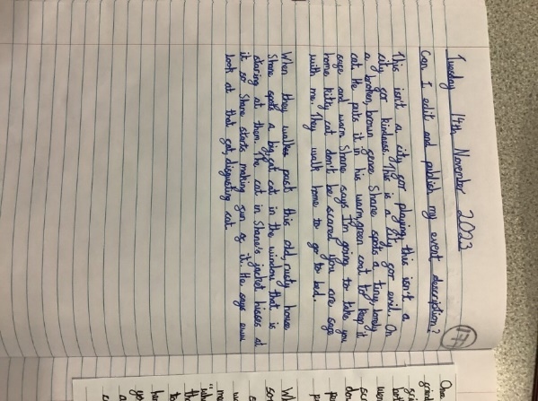
Y5 | Sentence Construction and Conjunctions.
- Use a wide range of clause structures, including relative clauses (beginning with a relative pronoun (who, which, whom, whose, that) or with an implied (i.e. omitted) relative pronoun), sometimes varying their position within a sentence.
- Use multi-clause sentences incorporating both co-ordination, embedded information and subordination
 | Noun Phrases
- Confidently use a variety of precise and effective expanded noun phrases containing adjectives, relative pronouns, nouns and prepositions
- Use expanded noun phrases to convey complicated information concisely
 | Adverbials
- Indicate degrees of possibility using adverbs or modal verbs
- Confidently use a range of precise adverbs, including those suitable for non-fiction and factual writing
- Use adverbials confidently at different points of the sentence
 | Cohesion
 | - Use a variety of cohesive devices, both within and between paragraphs e.g. adverbials for time, number, place and manner
 | Verbs
- Use the simple past, present perfect, past perfect and progressive verbs forms in their writing
- Link ideas across paragraphs using tense choices e.g. he had seen her before
- Use modal verbs to suggest degrees of possibility
 | Composition
- Write effectively for a range of purposes and audiences, using formal and informal language, as appropriate
- Present texts appropriately according to audience, purpose and format
- Use techniques from authors to develop character and settings
- Develop character through description, dialogue and action
- Able to write for a sustained period of time
- Plan, draft, evaluate, edit and revise writing
- Note and develop initial ideas, drawing on reading and research where necessary
- Assess the effectiveness of their own and others’ writing and suggest improvements
 | Punctuation
- Accurately use punctuation from Years 1-4:
• full stops, question marks and exclamation marks
• commas for lists
• commas for fronted adverbials
• commas to mark subordinate clauses
• apostrophes for possession (singular and plural) and contraction
• mark speech – both inverted commas and related punctuation
- Use brackets, dashes and commas to indicate parenthesis
- Use commas to clarify meaning or avoid ambiguity
- Accurately use ellipsis to indicate missing information
 | Handwriting
- Write fluently and legibly, using joined script.
- Use different styles of handwriting for different purposes with a range of media, including using capital letters to fill on forms and printing to label a diagram.
- Use consistent letter sizing across all writing and ensure that ascenders and descenders are an appropriate length.
 | Spelling
 | See NC 2014
 | Standard English
 | - Use the features of standard English and edit their writing as a result of this (see exemplification).
 | Terminology
 | Indefinite and definite article  Modal verbs, relative pronouns  Compound sentences, Complex sentences  Relative clause | Parenthesis (brackets, commas and dashes)  Cohesion and ambiguity  Progressive verb, present perfect verb, past perfect verb
Year 6
Y6 | 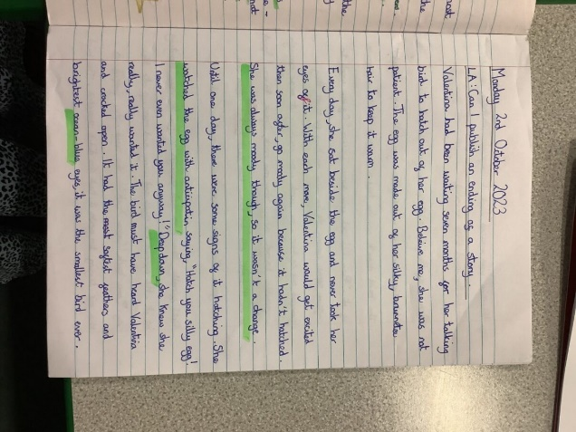
 | Sentence Construction and Conjunctions
- Use a wide range of clause structures, including relative clauses (beginning with a relative pronoun(who, which, whom, whose, that) or with an implied (i.e. omitted) relative pronoun), sometimes varying their position within a sentence
- Use multi-clause sentences incorporating both coordination, embedded information and subordination
 | Noun Phrases
- Confidently use a variety of precise and effective expanded noun phrases containing adjectives, relative pronouns (and omitted), prepositions to add detail, qualification and precision
- Use expanded noun phrases to convey complicated information concisely
 | Adverbials
- Indicate degrees of possibility using adverbs or modal verbs
- Use adverbials confidently at different points of the sentence
- Confidently use a range of precise adverbs, including those suitable for non-fiction and factual writing
 | Cohesion
 | - Use a range of devices to build cohesion within and across paragraphs e.g. conjunctions, adverbials of time, manner and place, pronouns, synonyms, repetition and ellipsis
 | Verbs
- Use verb tenses consistently and correctly throughout their writing
- Use the simple past, present perfect past perfect and progressive verb forms in their writing
- Link ideas across paragraphs using tense choices e.g. he had seen her before
- Use passive verbs to affect how information is presented
- Use modal verbs to suggest degrees of possibility
 | Composition
- Write effectively for a range of purposes and audiences, selecting language that shows hood awareness of the reader (e.g. use first person in a diary, direct address in instructions and persuasive writing)
- In narratives, describe characters, setting and atmosphe
- In narratives, integrate dialogue to convey character and advance the action
- Select vocabulary and grammatical structures that reflect what the writing requires, doing this mostly appropriately (e.g. contracted form in dialogues, passive verbs to affect how information is presented, modal verbs to suggest degrees of possibility)
- Be able to write for a sustained period of time
- Use techniques from authors to develop character and settings
- Plan, draft, evaluate, edit and revise writing
- Note and develop initial ideas drawing on reading and research where necessary
- Present texts appropriately according to audience, purpose and format
- Assess the effectiveness of their own and others’ writing and suggest improvements
 | Punctuation
- Use the range of punctuation taught at Key Stage 2 (and Key Stage 1) mostly correctly
- Full stops, question marks and exclamation marks
- Commas for lists
- Commas for fronted adverbials
- Commas to make subordinate clauses
- Apostrophes for possession (singular and plural) and contraction
- Accurately punctuate speech
- Brackets, dashes or commas to indicate parenthesis
- Semi-colon, colon and dah mark the boundary between independent clauses
- Use the colon to introduce a list and semi-colons with lists
- Bullet points to list information
- Hyphens to avoid ambiguity e.g. man eating shark, man-eating shark
- Use commas to clarify meaning or avoid ambiguity
- Accurately use ellipsis to indicate missing information

