 | Year 6
Enquiry name | How are lives saved? | What are shadows? | What does it mean to adapt? | How big is your footprint?
Picture Book Links | 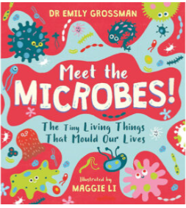 | 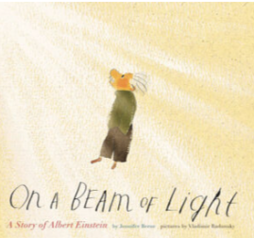 | 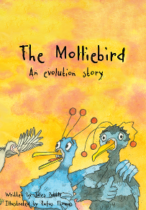 | 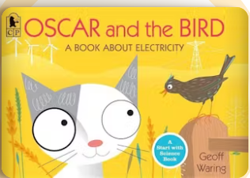
Disciplinary Knowledge – Enquiry Types | Observing over time:  • Observe pulse rates before, during and after exercise  Pattern seeking:  Children generate questions for investigation such as:  ▪ Do older people have lower pulse rates?  ▪ Do boys have higher pulse rates?  Comparative/Fair testing:  • Complete different activities to compare the impact on their own heart rate.  Researching:  • Generate questions to research about the human circulatory system. | Comparative/Fair testing:  • Investigate the shape of shadows and link this to light travelling in straight lines | Classifying:  • Classify animals according to Carl Linnaeus’ system.  • Classify plants into flowering, mosses, ferns and conifers, based on specific characteristics.  • Create a branching database/dichotomous key to classify a set of living things.  To show variation in a species:  ▪ Classify a species of animal e.g. cats, dogs  ▪ classify a species of plant e.g. daffodils, tulips, lilies  Pattern seeking:  • Use different pieces of equipment, e.g. chopsticks, toothpicks, cutlery, to look for patterns linking the suitability of bird beaks for the available food e.g.  rice, grapes, raisins.  Researching:  • Research the characteristics of a vertebrate/invertebrate group.  • Research the characteristics of flowering plants, mosses, ferns and conifers.  • Research the difference between bacteria, virus and fungi to give reasons why these are not plants or animals.  • Research how micro-organisms can be helpful or harmful.  • Research unusual animals e.g. axolotl, platypus, kangaroos etc.  • Research different types of a species and their characteristics making them suitable for different habitats e.g. penguins | Comparative/Fair testing:  • Investigate the effect of adding more bulbs to a circuit.  • Investigate the effect of adding more cells to a circuit.  • Investigate the effect of adding more buzzers to a circuit.  • Investigate the effect of adding more motors to a circuit.
Disciplinary Knowledge – Science skills | Asking questions  Setting up tests  Recording data  Interpreting and communicating results | Asking questions  Making predictions  Setting up tests | Evaluating  Interpreting and communicating results | Asking questions  Making predictions  Observing and measuring  Recording data
Substantive Knowledge: Living things/ Animals/ Plans/ Habitats | Know that the heart and lungs are organs protected by the ribcage.  Know that blood travels around the body transporting nutrients that have been absorbed into the blood stream from digestion; blood also carries oxygen around the body which is used to power the body; this use of oxygen to create energy is called respiration.  Know that the heart beats, pumping blood around the body and that blood vessels carry the blood; arteries carry blood away from the heart; veins carry blood towards the heart; capillaries are tiny blood vessels that connect arteries and veins.  Know that the heart is composed of four chambers: two atria and two ventricles; the aorta is the largest artery in the body and most major arteries branch off from it.  Know that when we exercise, our heart beats more frequently so that the oxygen that is used around the body can be replenished; it returns to a resting heart rate afterwards; fitter people tend to have lower resting heart rates.  Know that drugs are chemicals that have an impact on the natural chemicals in a person’s body.  Know that drugs can be harmful or helpful, depending on what they are and how they are used.  Know that all drugs can be harmful if overused.  Know that paracetamol and aspirin are examples of drugs that can be helpful as a painkiller.  Know that cannabis and cocaine are examples of illegal drugs that can have serious negative effects.  Know that alcohol and tobacco are examples of drugs that are legal to adults but that can have serious negative effects, such as liver disease and lung disease, respectively. |  | Know that all life on Earth began from a single point around 4.5 billion years ago.  Know that living things changes over time and that this gradual change is called evolution.  Know that natural selection is the cause of this change; natural selection works as across a species there is natural variation within a species; there is also competition to survive and reproduce and that members of a species with advantageous characteristics survive and reproduce-these characteristics are passed down to their offspring; members of a species with less advantageous characteristics do not survive and reproduce–these characteristics are not passed down to offspring.  Know that offspring vary and are not identical to their parents.  Know that Charles Darwin posited this theory of evolution by natural selection.  Know that the gradual change of species over millions of years can be observed by looking at examples of fossil.  Know that there are three types of micro-organism: viruses, fungi and bacteria; of these three, viruses are often not really considered to be alive by many scientists mainly because they don’t have the ‘machinery’ to reproduce inside them.  Know that germs are disease-causing bacteria.  Know that an arthropod is an invertebrate with a hard, external skeleton and jointed limbs.  Know that insects are a type of arthropod; their bodies consist of six legs, a head, a thorax and an abdomen; most insects also have a pair of antennae and a pair of wings.  Know that an arachnid (e.g. spider) is a type of arthropod with eight legs and no antennae or wings.
Substantive Knowledge: Seasonal Changes / Earth & Space
Substantive Knowledge: Materials
Substantive Knowledge: Forces & Energy |  | Know that translucent objects allow some light to pass through, but some of the light changes direction as it passes through the object; this means that something seen through a translucent object is not clearly defined.  Know that when light passes from one medium to another (e.g. from air to water), it changes direction; this is called refraction; this happens because light travels at different speeds in different media.  Know that white light comprises all the colours of light.  Know how to draw a diagram to show why the shape of a shadow will match the shape of an object.  Know that when light reflects off an object, the angle of incidence is equal to the angle of reflection.  Know that a periscope takes advantage of the predictable angles of incidence and reflection to allow an image to be shown to a viewer. |  | Know that voltage is a measure of the power of a cell to produce electricity; it is a measure of the ‘push’ of electric current, not the size of the electric current.  Know that as the number and voltage of cells in a circuit increases, the brightness of a bulb or the volume of a buzzer will increase (though too high a voltage may ‘blow’ the bulb or buzzer).  Know how to draw simple circuit diagrams.  Know the recognised symbols for a battery, bulb, motor, buzzer and wire.  Know how to predict whether components will function in a given circuit, depending on whether or not the circuit is complete; whether or not a switch is in an on or off position; and whether or not there is a cell to provide electrical current to the circuit.  Know that two bulbs in a circuit can be wired up to create a series circuit or a parallel circuit; if one bulb blows in a series circuit the other will not shine as the circuit has been broken; in contrast, if one bulb blows in a parallel circuit, there will still be a complete circuit for the other bulb so it will continue to shine; use this knowledge to explain the advantages of using parallel circuits (e.g. in the lighting in homes).
Assessed Substantive Knowledge | 1. Describe the changes that humans go through as develop from a baby into adulthood and then into old age using scientific vocabulary.  2. Name the key parts of the circulatory system and their function.  3. Understand some of the impacts that drugs and lifestyle can have on the body.  4. Describe how nutrients are transported within animals, including humans. | 1. Recognise that light appears to travel in straight lines through investigation opportunities  2. Explain that objects can be seen because they reflect light.  3. Explain why shadows have the same shape as objects. | 1. Name the different groups into which animals can be grouped.  2. describe how an animal  could be grouped based on specific characteristics. | 1. Investigate and describe the effect that the number of cells in a circuit has on the loudness of a buzzer and the brightness of a bulb.  2. Compare and give reasons for the variations in how components function.  3. Draw a simple series circuit using the recognised symbols.

