 | Year 5
Enquiry name | What does Earth look like from space? | How can science help the vulnerable? | What do forces actually do? | How can we help to save our planet?
Picture Book Links | 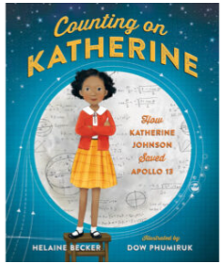 | 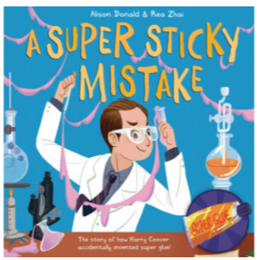 | 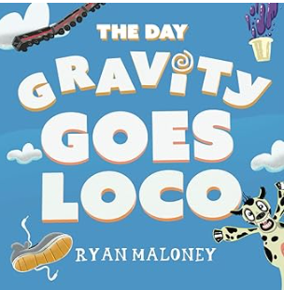 | 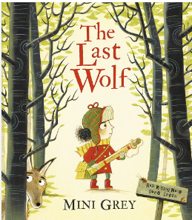
Disciplinary Knowledge – Enquiry Types | Observing over time:  • Measure shadows throughout the day.  Researching:  Generate questions to research about the Earth and space. | Classifying:  Based on the children’s own criteria:  ▪ classify the materials themselves e.g. samples of wood, metal, plastic, etc.  ▪ After observing what happens when solids are added to liquids, classify materials based on the outcomes.  Comparative/Fair testing:  • Which material would be good for a tent?  • Which materials keep things warm/cold?  • Which material would be good for a product to help the vulnerable?  • Test solids for solubility.  • Compare rates of solubility. | Comparative/Fair testing:  • Compare friction e.g. trainers or weighted match box pulled with force meter, balloon rockets, CD hovercraft, balloon cars.  • Compare water resistance, plasticine in a cylinder of liquid (easier with a more viscous liquid e.g. bubble bath).  • Compare air resistance e.g. spinners, parachutes,  • Compare levers, pulleys and gears.  Researching:  Research Heath Robinson and Rube Goldberg machines | Classifying:  •Classify animals according to their life cycle.  Observing over time:  • Grow from seeds and observe whether they grow roots/stem/ leaf/flower.  Pattern seeking:  Children generate questions such as:  ▪ Do larger mammals have longer gestation periods?  ▪ Do larger animals live longer?  ▪ Do smaller animals lay more eggs?  Researching:  Generate questions to research the life cycle of a chosen animal: mammal, amphibian, insect, bird e.g. dragon fly, cuckoo, salmon, worm, owl.
Disciplinary Knowledge – Science skills | Setting up tests  Asking questions | Asking questions  Making predictions  Recording data | Asking questions  Setting up tests  Recording data  Evaluating  Interpreting and communicating results | Making predictions  Observing and measuring
Substantive Knowledge: Living things/ Animals/ Plans/ Habitats |  |  |  | Know that the life cycle of a living thing is a series of stages of development starting with a fertilized egg in animals or a seed in many plants.  Know that in most mammals (e.g. dogs) a fertilized egg develops in the womb into an embryo and is then born and fed on milk before it is weaned onto the food that is adapted to eat; it then develops to maturity in a period called adolescence after which it can reproduce, and the cycle can begin again.  Know that in amphibians (e.g. frogs) a fertilized egg develops into an embryo and then hatches into a tadpole; the tadpole develops adult characteristics, metamorphoses into the adult form after which it can reproduce, and the cycle can begin again.  Know that in many insects (e.g. butterflies) a fertilized egg develops into wingless feeding form called a larva (caterpillar); the larva feeds then later becomes a pupa (chrysalis) with a protective cocoon; inside this cocoon, the pupa metamorphoses into the adult butterfly after which it can reproduce, and the cycle can begin again.  Know that in birds (e.g. robins) a fertilized egg hatches in a nest (a hatchling) and is fed by its parents until it is ready to fly (i.e. becomes a fledgling); it then leaves the nest and grows into an adult after which it can reproduce, and the cycle can begin again.  Know that humans go through stages of development; they begin as fertilized eggs and then develop into embryos before developing into babies; once they are born, these newborn babies become infants (roughly 2 months to 2 years) then into young children (roughly 2-12 years old); children develop into adults during adolescence (roughly 12-16 years old) at which age they become physically capable of reproduction; as adults develop into old age they experience changes in their body which require them to move more carefully and rest more frequently.
Substantive Knowledge: Seasonal Changes / Earth & Space | Know that a celestial body is a large object in the universe.  Know that the Sun is a star.  Know that a planet (e.g. Earth) is defined as a spherical celestial body that orbits a star.  Know that there are eight major planets in our solar system: Mercury, Venus, Earth, Mars, Jupiter, Saturn, Uranus, Neptune.  Know that the universe is utterly vast and that our solar system makes up a tiny fraction of the universe.  Know that a satellite orbits a planet and that moons are natural satellites.  Know that the Moon orbits the Earth roughly every 28 days.  Know that as the Moon orbits the Sun, different parts of it are lit up by the Sun, which is why we see a different shape lit up on the Moon as the lunar cycle progresses.  Know that all the planets in the solar system orbit the Sun and that the further away they are from the Sun, the longer their orbit.  Know that the Earth spins around an imaginary line through its centre called an axis and that this axis is tilted relative to the Earth’s orbit.  Know that night and day are the result of the Earth rotating on its axis.  Know that the tilt of the Earth towards and away from the Sun’s light as the Earth orbits the Sun leads to the seasons as during winter the light is spread over a wider area.
Substantive Knowledge: Materials |  | Know that materials can be sorted in a variety to ways based on their properties.  Know that in some solid materials the bonds between particles break when surrounded by a liquid; this allows the liquid to absorb the solid; when this happens, the solid is called a solute, the liquid is called a solvent and the result is a solution; when a solid does dissolve in a liquid it is described as being soluble in that solvent (e.g. sugar in water); when it cannot it is insoluble (e.g. sand in water).  Know that a given amount of solvent can only absorb a certain amount of solid before no more will dissolve; when this happens, the liquid is said to be saturated.  Know that when a solvent is evaporated from a solution, the original solute is left behind; the remaining solid will often form crystals–the slower the solvent evaporates, the larger the crystals that will be formed.  Know how to dissolve a solute in a solvent and then how to evaporate the solvent to recover the solute.  Know that a reversible change is one that can be reversed and that examples of this are mixing, dissolving and changes of state where no chemical reaction takes place.  Know that an irreversible change is one that cannot be reversed and that examples of this often involve a chemical change where a new material is made, often a gas (e.g. burning, boiling an egg, the reaction of bicarbonate of soda and acid).  Know that filtering allows solids and liquids to be separated and that sieving allows solids made up of different sizes parts to be separated.  Know how to separate a mixture of sand, salt and small stones by sieving (to remove the small stones), followed by dissolving in water (so the salt is absorbed), followed by filtering to remove the sand from the mixture, followed finally by evaporation of the water to recover the salt.  Know that materials’ different properties can be tested through acting upon them, including testing to find whether materials are magnetic, thermally conductive and electrically conductive.  Know that the various properties of different materials make them suitable for a given function.  Know how to explain orally and in writing the reasons why various materials are suited or unsuited to a function.
Substantive Knowledge: Forces & Energy |  |  | Know that a force is measured in a unit called Newtons, named after a British scientist, called Sir Isaac Newton who discovered lots about gravity and how planets move.  Know that pull forces can be measured using a device called a force meter.  Know that the amount of matter (stuff) in an object is its mass.  Know that gravity is a force that acts between all objects in the universe, but that it acts much more strongly between objects that have more mass and that are close together.  Know that unsupported objects are pulled towards the Earth by the force of gravity.  Know that air resistance is a force felt by an object as it moves through the air; it is caused by the object bumping into the gas particles that make up air; the quicker an object moves, the more gas particles it bumps into and the more air resistance it experiences.  Know that a parachute’s shape increases the air resistance that a falling object experiences.  Know that water resistance is a force felt by an object as it moves through water; it is caused by the object bumping into the water particles.  Know that the shape of an object determines how much air resistance or water resistance it experiences; shapes of object that experience little air resistance or water resistance are described as streamlined.  Know how to draw a force diagram with arrows representing the different forces acting on an object.  Know that a lever is a rigid length pivoting around a fulcrum.  Know that a pulley is a wheel with a fulcrum that supports a moving cable or belt.  Know that a gear is a rotating wheel with cut teeth that mesh with the teeth of another gear so that turning one gear turns an adjacent gear in the opposite direction.  Know that gears, levers and pulleys are simple machines that used to allow a smaller force to have a greater effect; they do this by moving a smaller force over a longer distance at one end of the machine, which the machine turns into a larger forcer over a small distance at the other end.
Assessed Substantive Knowledge | 1. Name some of the planets in the solar system.  2. Describe the movement of the earth and other planets relative to the sun.  3. Describe that the earth, sun and moon are approximately spherical bodies.  4. Explain day and night and the apparent movement of the sun across the sky using the idea of the Earth’s rotation. | 1. Compare and group materials based on their hardness, solubility, transparency, conductivity and response to magnets.  2. Understand how solutions are made.  3. Describe a method of separating mixture.  4. Conduct a fair/comparative test to test the suitability of uses of everyday materials.  5. Describe 1 irreversible change of state.  6. Describe 1 reversible change of state. | 1. Explain the effect that gravity has on objects  2. Explain the effect (air resistance/water resistance or friction) can have on a moving object  3. Recognise that some mechanisms allow a smaller force to have greater effect. | 1. Explain the life cycle of 1 mammal, amphibian, insect and bird.  2. Describe some of the differences in life cycles.  3. Describe the life processes of reproduction in some animals and plants.

