 | Year 4
Enquiry name | Where does our water come from? | Why is water pollution a problem? | What is sound? | How can we switch off? | What keeps us healthy inside?
Picture Book Links |  | 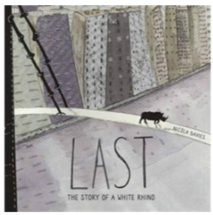 | 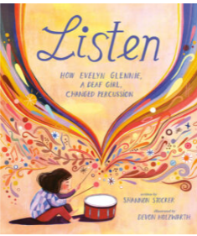 | 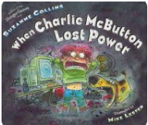 | 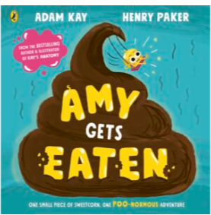
Disciplinary Knowledge – Enquiry Types | Classifying:  Based on the children’s own criteria:  ▪ classify solids (including grains, crystals, powders: physical properties)  ▪ classify liquids  Observing over time:  • Watch ice melt (ice hands).  • Watch hand prints dry e.g. water hand prints on coloured paper towel.  • Watch frozen liquids melt.  Comparative/Fair testing:  • What affects the melting rate of chocolate (size of pieces, temperature of water, type of chocolate)?  • What affects the rate an ‘ice pole’ melts?  • What affects the rate of evaporation?  Researching:  •Research the water cycle. | Classifying:  Based on the children’s own criteria:  ▪ classify a number of living things in their local environment (plants and animals)  ▪ classify a number of living things in the wider environment (plants and animals) after completing research  ▪ introduce branching databases/dichotomous keys.  Pattern seeking:  •Do animals with …. have ….?  • Do plants with …. have ….?  Researching:  • Research and be able to name plants and animals in the wider environment e.g. polar, desert, jungle, etc.  • Research global environmental issues and their impact on living things | Classifying:  • Based on the children’s own criteria, sort musical instruments  Comparative/Fair testing:  • Measure volume from different instruments.  • Measure how volume changes away from a source.  • Investigate string telephones.  • Explore pitch e.g. through a carousel of activities using milk bottles, straw pipes, rulers, elastic band guitars.  Researching:  Research, make and play their own instruments based on what they learned about pitch and volume. | Classifying:  • Based on the children’s own criteria, classify household appliances and/or toys (leading to electrical/not electrical, batteries/mains).  • Test materials to classify into insulators and conductors. | Classifying:  • Compare and contrast different types of teeth (linking to simple functions).  • Classify jaw bones/teeth to aid with making food chains e.g. recognise what eats plants and what eats animals by looking at their teeth.  Researching:  • Research the different parts of the digestive system.  • Research what different animals eat within a specific environment, e.g. coral, polar, African grasslands, in order to construct food chains.
Disciplinary Knowledge – Science skills | Asking questions  Setting up tests  Recording data  Interpreting and communicating results | Asking questions  Making predictions  Setting up tests | Making predictions  Observing and measuring  Evaluating | Observing and measuring  Evaluating | Observing  Interpreting and communicating results
Substantive Knowledge: Living things/ Animals/ Plans/ Habitats |  | Know that animals can be grouped based on their physical characteristics (e.g. vertebrates and invertebrates) and based on their behaviour (e.g. herbivores, carnivores and omnivores).  Know that living things are divided into kingdoms: the animal kingdom, plants, fungi, bacteria, and single-celled organisms.  Know that a species is a group of living things have many similarities that can reproduce together to produce offspring.  Know that a classification key uses questions to sort and identify different living things.  Know how to use a classification key to identify living things.  Know how to create a classification key to sort plants on the school premises.  Know that changes to the environment can make it more difficult for animals to survive and reproduce; in extreme cases this leads to extinction, where an entire species dies.  Know that human activity–such as climate change caused by pollution-can change the environment for many living things, endangering their existence.  Know that the polar bear is a famous example of climate change endangering the existence of a species; as the climate changes and gets warmer, the sea ice on which polar bears live reduces in amount making it harder for them to survive and reproduce. |  |  | Know that food passes through the body with the nutrients being extracted and the waste products excreted, and that this process is called digestion.  Know that the process of digestion involves breaking complex foodstuffs into simpler building blocks that can be absorbed by the body.  Know that the process of digestion begins with food being chewed in the mouth by the teeth and saliva added.  Know that a human has three types of teeth–incisors, canines and molars–and that these each perform different functions.  Know that incisors slice food, canines tear food (especially meat) and that molars grind food.  Know that children develop an initial set of teeth which are gradually replaced between the ages of 6 and 12.  Know that food is squeezed down the oesophagus towards the stomach.  Know that the stomach releases acid and enzymes to continue breaking down the food; the stomach is an organ; an organ is a part of living thing that is self-contained and has a specific important job.  Know that food is broken down as it travels through the intestines where nutrients and water are absorbed.  Know that undigested food is stored in the rectum before being excreted through a muscle called the anus.  Know that a food chain traces the path of energy through a habitat.  Know that all energy for a food chain initially comes from the Sun which is absorbed and turned into energy by plants which are called producers.  Know that consumers take in energy by eating.  Know that an animal that is eaten by another is called prey, and that an animal that eats other animals is called a predator.  Know that the arrows in a food chain show the direction that energy is travelling.
Substantive Knowledge: Seasonal Changes / Earth & Space
Substantive Knowledge: Materials | Know that things are composed of a material in one of three states of matter: solid, liquid or gas.  Know that things are made of particles (tiny building blocks) and that these are organised differently in different states.  Know that materials can change state when temperature changes.  Know that there are bonds between the particles (building blocks) in a solid; as temperature increases, these bonds are somewhat overcome as the particles absorb energy and solids can change into liquids; with a further increase in temperature, the particles become even more energetic and the bonds are overcome entirely so the liquid changes into a gas.  Know that when solids turn into liquids, this is called melting and that the reverse process is called freezing.  Know that when liquids turn into gases, this is called evaporation and that the reverse process is called condensation.  Know that the melting point of water is 0°C and that the boiling point of water is 100°C  Know that water flows around our world in a continuous process called the water cycle.  Know that rain condenses in clouds and falls to earth as rain, snow or hail in a process called precipitation.  Know that water flows across the land in rivers and streams in a process called surface run-off and under the ground as groundwater.
Substantive Knowledge: Forces & Energy |  |  | Know that sound is a form of energy.  Know that sound is generated when an object vibrates; some of the energy from the vibrating object is transferred to the air, making the air particles move.  Know that sound travels through a medium (e.g. particles in the air) and thus sounds does not travel through a vacuum which has no particles in it at all.  Know that longitudinal sound waves are detected in the ear by humans and that the brain interprets this as the sounds we hear.  Know that pitch is how high or low a sound is and that this is determined by how many vibrations per second are being made by the vibrating object.  Know that volume is how loud or quiet a sound is and that this is determined by the amount of energy in the wave (e.g. from how hard or soft a percussion instrument is hit).  Know that the volume of a sound is quieter if the listener is further away from the object. | Know that electrical energy is one of many forms of energy.  Know that electrical current flows well through some materials, called electrical conductors, and poorly through other materials, called electrical insulators.  Know that electrical conductivity (how well a material conducts electricity) is an example of a property.  Know that metals are good electrical conductors.  Know that more than one cell lined up to work together is called a battery.  Know that electrical current can flow if there is a complete circuit.  Know that wires–which contain a conductor inside them, usually made of metal–can allow electrical current to flow around a circuit.  Know that when electrical current flows through circuit components within that circuit–such as buzzers which make a noise and bulbs which emit light–begin to work.  Know that a switch functions by completing or breaking a complete circuit.  Know how to construct a simple circuit using components.  Know that exposure to high levels of electrical current can be dangerous.
Assessed Substantive Knowledge | 1. Identify if a material is a liquid, gas or solid.  2. Describe how some materials can change when heated.  3. Describe how some materials can change when cooled.  4. Measure temperatures accurately in degrees Celsius.  5. Describe the water cycle using the key vocabulary (condensation and evaporation). | 1. Understand that living things can be grouped in different ways.  2. Use a classification key to identify living things.  3. Explain some of the ways the environments can change and the danger it can pose. | 1. Explain how we hear sounds using correct scientific vocabulary.  2. Identify pattern between volume and the strength of vibrations.  3. Identify patterns between pitch and the features of an object that produces the sound.  4. Describe that sounds get fainter as the distance from the sound increases. | 1. Name 3 appliances that run off electricity. 2. Independently construct a simple series circuit. 3. Name the common components of a simple series circuit.  4. Recognise that a switch opens and closes a circuit. 5. Name 2 common insulators and conductors. | 1. Describe the simple functions of the digestive system using scientific vocabulary.  2. Name the 3 different types of teeth and their functions.  3.Construct 2 different food chains that have a producer, predator and prey.

