 | Year 3
Enquiry name | How can we feel the force? | How do plants work? | What is the difference between surviving and being healthy? | What is darkness? | What is underneath my feet?
Picture Book Links | 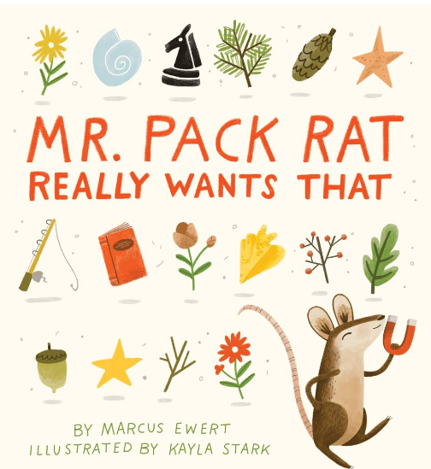 | 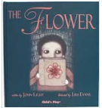 | 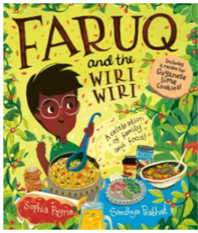 | 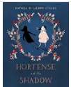 | 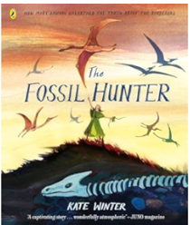
Disciplinary Knowledge – Enquiry Types | Classifying:  Based on the children’s own criteria:  ▪ sort materials (leading towards metal/non-metal and magnetic/not magnetic)  ▪ sort toys (leading to what makes them move e.g. push/pull).  Comparative/Fair testing:  ▪Test how objects move on different surfaces e.g. cars, spinning tops, wind-up/clockwork toys.  • Test the strength of different magnets.  Research:  •Find out how magnets are used in everyday life. | Classifying:  Classify flowers based on the children’s own criteria. (This does not meet the curriculum objectives for this topic, but it is a good opening activity to  assess prior knowledge.)  Observing over time:  •Observe celery (with roots and leaves) in coloured water.  • Observe white carnations (freshly cut) in coloured water.  Pattern seeking:  •Investigate what happens when conditions are changed e.g. more/less light/water, change in temperature, nutrients (Baby Bio vs other brands).  Researching:  •Research the functions of the parts of flowering plants.  • Research different methods of seed dispersal.  • Research different methods of pollination. | Classifying:  Based on the children’s own criteria:  ▪ classify food items (leading to sorting by nutrients)  ▪ classify animals (leading to sorting by whether or not they have skeletons).  Pattern seeking:  Children generate questions for investigation such as:  ▪ Do ‘healthy’ drinks have less sugar?  ▪ Does brown bread have more fibre?  ▪ Do people with long arms throw further?  ▪ Can people with short legs jump higher?  ▪ Can people with longer legs run faster?  ▪ Can people with bigger hands catch a ball more easily?  Researching:  ▪Look at food packaging to identify the amount of nutrients in different food items.  • Research which types of food contain which nutrients.  • Generate questions to research about the human skeleton. | Classifying:  Based on the children’s own criteria:  ▪ classify light sources (leading to man-made/natural)  ▪ classify materials (leading to reflective/non-reflective, transparent/translucent/opaque)  Comparative/Fair testing:  Test materials for reflectiveness.  • Test materials for transparency.  • Investigate shadows (size of shadows, shape of shadows). | Classifying:  •Based on the children’s own criteria, classify rocks. (At the beginning of the topic, this will most likely focus on appearance, leading to physical properties at the end of the unit.)  • Look at different soils and discuss how they are similar/different.  Observing over time:  • Observe how soil separates into different layers in water  Comparative testing:  •Test the hardness of different rocks.  • Test what happens when rocks are put in water.  • Test how quickly water runs through different types of soil.  Researching:  • Research how fossils are formed.
Disciplinary Knowledge – Science skills | Asking questions  Setting up tests  Observing and measuring | Evaluating  Asking questions  Making predictions  Interpreting and communicating results | Asking questions  Observing and measuring  Recording data | Making predictions  Setting up tests  Recording data | Evaluating  Observing and measuring  Interpreting and communicating results
Substantive Knowledge: Living things/ Animals/ Plans/ Habitats |  | Know that different parts of plants have one or more functions (jobs).  Know that the roots collect water and minerals from the soil, and hold the plant firmly in the ground.  Know that the stem holds up the leaves so that they can gather light to make food and holds up the flowers so that they can receive pollen and disperse their fruits.  Know that the stem also transports water and minerals from the roots to the other parts of the plant.  Know that the leaves make food by trapping light and using its energy to turn carbon dioxide and water into carbohydrates.  Know that the function of a flower is reproduction, where flowers of the same kind exchange pollen–made by an anther–in a process called fertilisation, and a structure in the flower’s ovary called an ovule becomes a seed; the ovary then becomes a fruit which helps the seed leave the plant in a process called dispersal. | Know that proteins are good for growth, carbohydrates for energy and fruit and vegetables provide vitamins and minerals which help keep us healthy (e.g. calcium for healthy bones and teeth)  Know that getting the right amount of each food group (including over half of the diet made up of fruit, vegetables and carbohydrates) is called a balanced diet.  Know that lack of a nutrient can cause ill health.  Know that excess of a food group can cause ill health, such as tooth decay due to excess sugar.  Know that excess fat from fatty foods such as butter and cheese-and created in the body from excess calories–builds up in the body and can cause obesity.  Know that animals, including humans, have a skeleton made up of solid objects.  Know that some animals (such as insects) have an exoskeleton–a solid covering on the outside of their body.  Know that many invertebrates (such as earthworms and slugs) have water held inside by muscles which act like a skeleton.  Know that skeletons provide support for muscles and protect the body; for example, the rib cage protects the vital organs in the human body.  Know that human skeletons are made up of bones and cartilage.  Know that muscles can only contract, so they must be arranged in pairs in the body so that as one contracts the other loosens.
Substantive Knowledge: Seasonal Changes / Earth & Space |  |  |  | Know that the Sun is a light source, but that the Moon is not.  Know that sunglasses can protect eyes from sunlight but looking at the Sun directly–even with sunglasses–can damage the eyes.
Substantive Knowledge: Materials |  |  |  | Know that opacity/transparency and reflectiveness are properties of a material. | Know that there are three kinds of rocks: igneous, sedimentary and metamorphic.  Know that the Earth has a solid crust made up of tectonic plates with molten rock beneath.  Know that igneous rocks form from molten rock below the Earth’s crust and name at least 1 of granite, pumice or obsidian.  Know sedimentary rocks are formed when small, weathered fragments of rock or shell settle and stick together, often in layers. Name limestone or sandstone.  Know metamorphic rocks are formed when rocks in Earth’s crust get squashed and heated in processes such as when tectonic plates press against each other. Name marble or slate.  Know that fossils form when a plant or animal dies and is quickly covered with silt or mud so that it cannot be rotted by microbes or eaten by scavenging animals; in time layers of sediment build, squashing the mud and turning it to stone around the dead plant or animal; the materials in the body are replaced by minerals that flow in water through the rock, leaving a rock in the shape of the animal or plant that was once there  Know that soil is made from tiny particles of rock broken down by the action of weather (weathering).
Substantive Knowledge: Forces & Energy | Know that a force can be thought of as a push or a pull.  Know that objects move differently on rough and smooth surfaces; objects resist movement more on rough surfaces because there is higher friction as the object moves.  Know that there are also non-contact forces that can act between objects without them touching and that magnetism is an example of a non-contact force.  Know that magnets have two poles called north and south.  Know that like poles (south-south and north-north) of two magnets repel each other and that opposite poles of two magnets (north-south) attract each other.  Know that there is a magnetic field around a magnet which is strongest at each pole.  Know that some materials are magnetic, meaning that they are attracted to a magnet, while other materials are non-magnetic. |  |  | Know that light is a form of energy and that energy comes in different forms and can be neither created nor destroyed, only changed from one form to another.  Know that we need light to see things and that darkness is the absence of light.  Know that light travels in straight lines.  Know that light is reflected when it travels from a light source and then ‘bounces’ off an object.  Know that everything that we can see is either a light source or something that is reflecting light from a light source into our eyes.  Know that opaque objects block light creating shadows and that light passes through transparent objects.  Know that as objects move towards a light source, the size of the shadow increases.  Know how to show the changing of shadow size by drawing a diagram with straight lines representing light.  Know that a data logger can keep track of light levels and that this can be plotted on a graph to show how these change over the course of a day.
Assessed Substantive Knowledge | 1. Explain how objects move on different surfaces. 2. Describe how magnets either attract or repel each other.  3. Name a magnetic material.  4. Name 2 non-magnetic materials.  5. Group objects based on whether they are magnetic or not.  6. Understand that magnets have 2 poles. | 1. Describe the functions of each part of a flowering plant. 2. Explain what the requirements are for plant life and growth. 3. Explain how water is transported in plants.  4. Describe the part that the flower plays in the lifecycle of a plant. | 1. Explain that animals and humans need the correct nutrition.  2. Name 4 different types of nutrients.  3. Explain that humans and animals cannot produce their own nutrients.  4. Use correct vocabulary to describe the human Skelton and muscles.  5.Explain that skeletons and muscles are for protection and movement. | 1. Understand that light is needed to see things. 2. Understand that darkness is the absence of light. 3. Understand that light always has a source. 4. Know that some surfaces reflect light.  5. Explain that darkness is the absence of light.  6. Describe how shadows are formed when light is blocked. 7. Spot patterns in the way shadows change. 8. Understand that light from the sun can be dangerous and describe two ways that you can protect your eyes from sunlight. | 1. Name 3 different types of rock and describe their properties.  2. Group rocks together using properties and appearance. 3. Describe in simple terms how fossils are made. 4. Explain that soils are made from rocks and organic matter.

