 | Year 2
Enquiry name | What is home? | How do we live a healthy life? | How do plants grow? | What is my classroom made of?
Picture Book Links | 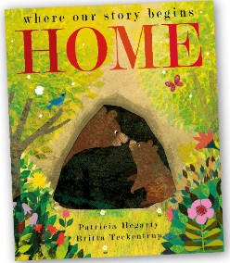 | 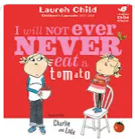 | 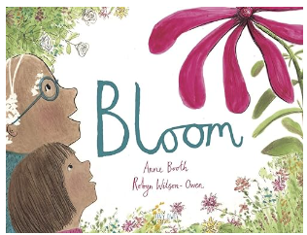 | 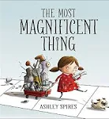
Disciplinary Knowledge – Enquiry Types | Classifying:  •Find things that are living.  • Find things that are dead.  • Find things that have never been alive.  • Classify things found in the environment (choosing their own criteria to do so), leading to living, dead and never been alive.  • Classify minibeasts found in the environment based on physical structure.  • Classify plants found in the environment.  Pattern seeking:  Children generate questions for investigation such as:  ▪ Are there more daisies in the meadow or on the field?  ▪ Where do you see more ivy?  ▪ Where do you see more butterflies?  Where do snails live?  Researching:  •Use secondary sources to name plants and animals seen in the local environment that they may not currently be able to name. | Classifying:  Based on the children’s own criteria:  ▪ classify food items  ▪ classify animals.  Observing over time:  •Observe a life cycle (e.g. caterpillars, chicks, farm animals).  • Observe how their body changes during/after exercise  Researching:  •Research adult animals and their young e.g. googling pictures and names of animal babies – swan and cygnet. | Classifying:  Based on the children’s own criteria:  ▪ classify seeds  ▪ classify bulbs.  Observing over time:  ▪Plant seeds and bulbs and observe how they grow.  Pattern seeking:  Children generate questions for investigation such as:  ▪ Do big seeds germinate more quickly?  ▪ Does it matter which way round you plant a bulb or seed?  ▪ Which comes first, the root or the shoot?  Researching:  Look at packets to decide how to plant and care for seeds e.g. How much water do they need? Do they need shade/full sun? | Classifying:  Based on the children’s own criteria:  ▪classify materials e.g. samples of wood, metal, plastic, etc.  Comparative/Fair testing:  Test materials for different uses (e.g. Which material can you use to make the different parts of your reading area? The seats, the floor, the windows, the cushions, the curtains, the ceiling]
Disciplinary Knowledge – Science skills | Asking questions  Observing and measuring | Asking questions  Observing and measuring | Setting up tests  Recording data  Interpreting and communicating results | Setting up tests  Recording data  Interpreting and communicating results
Substantive Knowledge: Living things/ Animals/ Plans/ Habitats | Know that plants and animals produced offspring that grow into adults.  Know that living things move, grow, consume nutrients and reproduce; that dead things used to do these things, but no longer do; and that things that never lived have never done these things.  Know that polar bears are an example of an animal adapted to its environment–thick fur for warmth and oily paw pads to ensure that they don’t freeze to the ice.  Know that sharks are another example–smooth skin and streamlined shape for quick swimming; and gills for breathing underwater.  Know that cacti are an example of a plant adapted to its environment–thick skin keeps a store of water safe; sharp spikes keep animals from stealing the water.  Know that pine trees have thick bark and pinecones to protect against cold winters.  Know that woodlice live under logs–an example of a microhabitat-as they need somewhere dark and damp so that they do not dry out.  Know that frogs can live in ponds–an example of a microhabitat- as they have water in which to lay their eggs (frogspawn). | Know that animals, including humans, need food, water and air to survive.  Know the basic food groups: fruit and vegetables, carbohydrates, protein, dairy, fat and sugary foods.  Know that more than half of our diet should be made up of carbohydrates, fruit and vegetables.  Know that fats and sugary foods should be eaten rarely and in small amounts.  Know that people need to exercise often to help their body stay strong and fit.  Know that keeping clean, including washing and brushing teeth, is an important part of staying healthy.  Know that plants absorb energy from the Sun; that this energy is consumed by herbivorous animals; and that carnivorous animals eat other animals.  Know that the arrows on a food chain show the direction that the energy travels. | Know that seeds and bulbs need to be buried underground in soil and that they will grow into adult plants under the right conditions (water, warmth).  Know that plants that are deprived of light, food or air will not grow and will die.  Know what plants need to grow and stay healthy (light, water & suitable temperature).
Substantive Knowledge: Seasonal Changes / Earth & Space
Substantive Knowledge: Materials |  |  |  | Know that materials can have useful properties for a given job (including being waterproof, strong, hard, soft, flexible, rigid, light or heavy.)  Know that many types of plastic are waterproof, that steel (a type of metal) is strong, that rock is hard, that cotton wool is soft, that rubber is flexible, that rock is rigid, that polystyrene (a type of plastic) is light, and that iron (a type of metal) is heavy.  Know that applying forces to objects can change their shape.
Substantive Knowledge: Forces & Energy
Assessed Substantive Knowledge | 1. Describe the life cycle of 1 animal (chicken/frog/butterfly)  2. Explain the differences between things that are living, dead, and things that have never been alive  3. Name 2 habitats and how these are suited to different animals. | 1. Describe the life cycle of a human  2. Describe what humans need to survive  3. Understand the importance of exercise and diet | 1. Describe what plants need in order to grow and stay healthy  2. Describe how seeds and bulbs grow into mature plants | 1. Compare the suitability of difference materials for different purposes  2. Name materials suitable for certain purposes  3. Describe how the shape of certain materials can be changed

