 | EYFS
Enquiry name | Who are we? | What is darkness? | What stories do we know? | Where does food come from? | How do we look after pets? | Where can we go?
Picture Book Links | 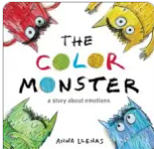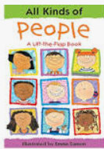 | 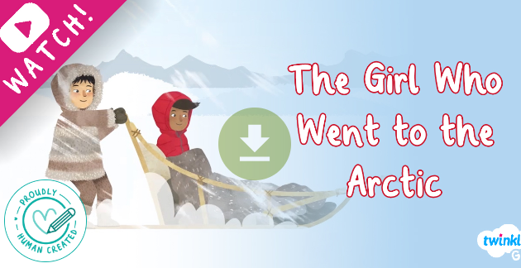 |  | 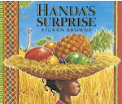 | 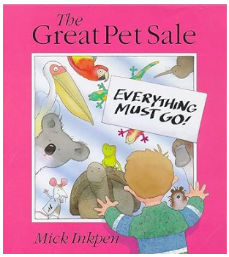 | 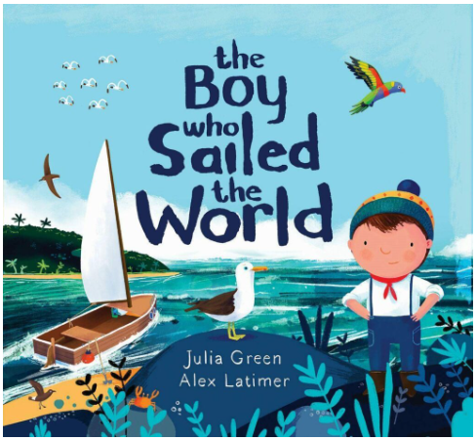
Disciplinary Knowledge/ Skills to Practice when Working Scientifically | Look closely at similarities, differences, patterns and change to do with people.  Make observations and explain observations about people.  Make observations about seasonal changes in Autumn | Look closely at similarities, differences, patterns and change to do with light and dark.  Make observations and explain observations about light and dark and hours of daylight.  Children question why things happen, forming their own ideas.  Carry out observations on changes such as melting ice, floating and sinking, magnets. |  | Look closely at similarities, differences, patterns and change to do with food.  Make observations and explain observations about food. | Look closely at similarities, differences, patterns and change to do with animals.  Make observations and explain observations about animals. | Look closely at similarities, differences, patterns and change to do with Summer.  Children question why things happen, forming their own ideas.
Substantive Knowledge: Living things/ Animals/ Plans/ Habitats | Children know about similarities and differences in relation to Living things - Body parts | Understand the importance of sleep for good hygiene.  Find out about Arctic and Antarctic habitats.  Children know about similarities and differences in relation to Places - Different animal habitats. – Arctic/Antarctic and the UK.  Making bigger/smaller shadows. |  | Children can make observations of plants and explain Why things occur and  talk about changes.  Understand which foods contribute to a healthy diet.  Children know about similarities and differences in relation to Objects - Fruits and vegetables. -  Find out about countries where different fruits can grow.  Children can examine change over time, for example, growing plants.  Talk about the parts of plants and what happens to them. Using the language: leaves, roots, stem, petal. | Children can make observations of animas and explain why things occur and talk about changes.  Children can look at different animals and their body parts.  Talk about why animals have different body parts e.g., beak, wings, leg.  Talk about the differences between animals.  Explore pond habitats and the plants and wildlife that live there.  Children find out what animals and humans need to be healthy. | Children can explore changes in the human body as they move up to year 1.
Substantive Knowledge: Seasonal Changes / Earth & Space | Talk about the changes that each season brings in relation to their environment: the clothes they wear, the weather and the plants – Autumn.  Being able to understand  significance and  difference between  seasons and months, | Discuss features of the environment and how environments  may vary from one another (ELG).  Talk about the changes that each season brings in relation to their environment: the clothes they wear, the weather and the plants – Winter.  Being able to understand  significance and  difference between  seasons and months, |  | Talk about the changes that each season brings in relation to their environment: the clothes they wear, the weather and the plants – Spring.  Being able to understand  significance and  difference between  seasons and months, |  | Talk about the changes that each season brings in relation to their environment: the clothes they wear, the weather and the plants – Summer.  Being able to understand  significance and  difference between  seasons and months,
Substantive Knowledge: Materials | Children can use different materials creatively to construct different objects.  Children can plan to use specific materials based on their features (e.g., - Waterproof and not waterproof. - Strong and weak. - Recyclable and not recyclable)
Substantive Knowledge: Forces & Energy |  | Look closely at similarities, differences,  patterns and change to do with light.  Explore light from different sources, exploring shadows e.g., using shadow puppets. | Look closely at similarities,  differences, patterns and  change e.g., exploring sounds made by different instruments

